**ASSIGNMENT**

CSC103-Programming Fundamentals



Submitted by:

**AHMAD BIN MUSTAFA**

**SP23-BCS-011**

**A**

Submitted to:

**Mr. Abdul Karim Shahid**

Submitted on: **March 13, 2023**

**Department of Computer Science**

**COMSATS University Islamabad**

**Lahore Campus**

**LAB TASK 2**

**Exercise 1:** Write a program to calculate the electricity bill. The rates of electricity per unit are as follow: If the units consumed are equal or less than 300, then the cost is Rs3/- per unit. If units consumed are more than 300, then the cost is Rs3.5/- per unit and surcharge of 5% of bill is added.

**PROGRAM**

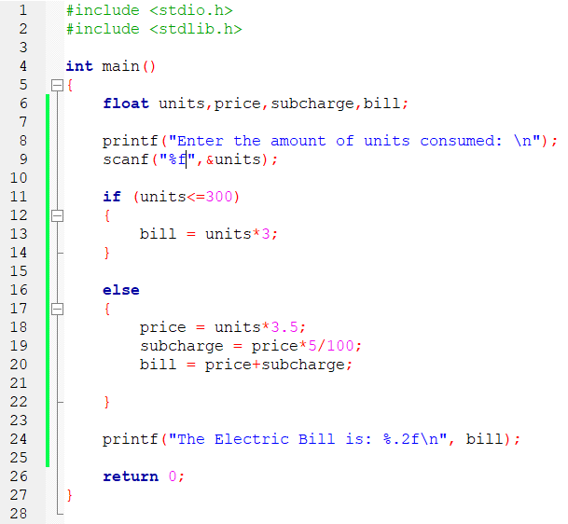

**OUTPUT**

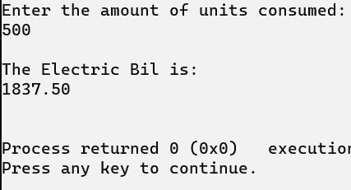

**EXERSICE 2: :** Write a program that reads 5 marks of different subjects out of 100 from the keyboard and determines and displays the sum and percentile of the marks. Then print grades and credit points on the basic of percentile as per following table: *TABLE*

**PROGRAM**

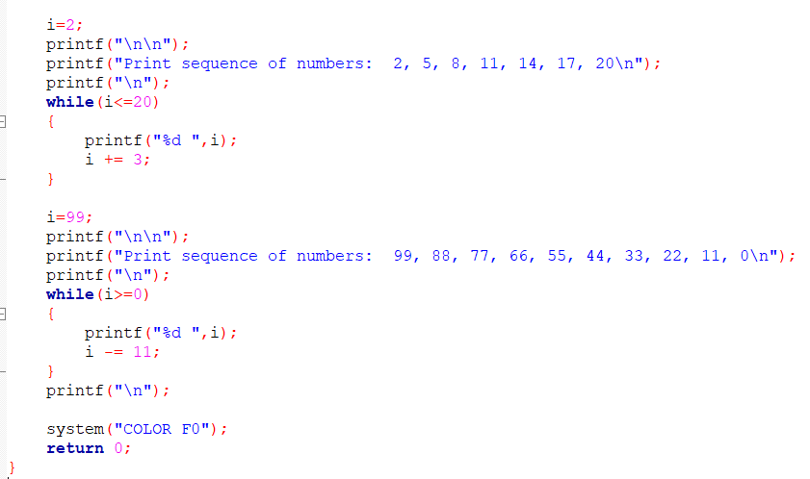

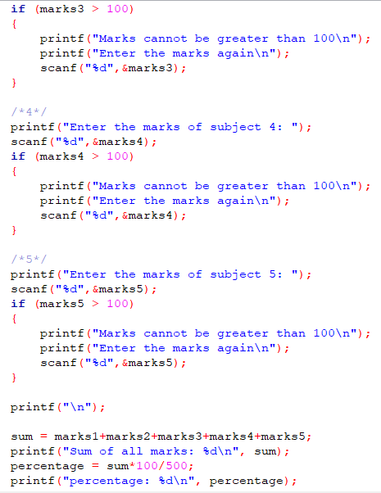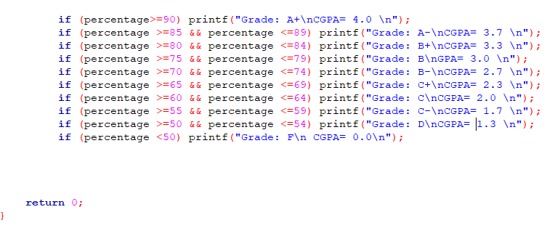

**OUTPUT**

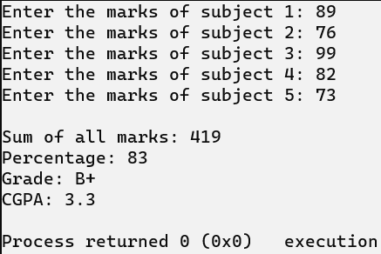

**EXERSICE 3:** While purchasing certain items, a discount of 10% is offered if the quantity purchased is more than 1000. If quantity and price per item are input through the keyboard, write a program to calculate the total expenses.

**PROGRAM**

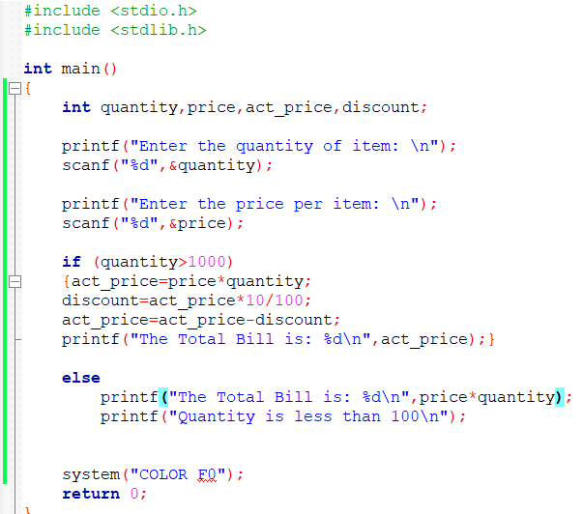

**OUTPUT**

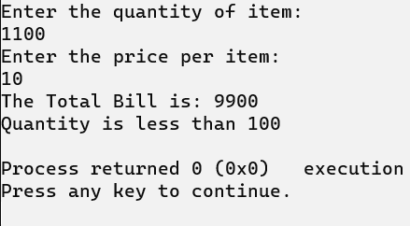

**EXERSICE 4:** A company insures its drivers in the following cases:

− If the driver is married.

− If the driver is unmarried, male & above 30 years of age.

− If the driver is unmarried, female & above 25 years of age.

In all other cases the driver is not insured. If the marital status, gender and age of the driver are the inputs, write a program to determine whether the driver is to be insured or not

Hint: For marital status you may ask user to enter 0 for married and 1 for unmarried. You may ask user to enter 0 for male and 1 for female.

**PROGRAM**

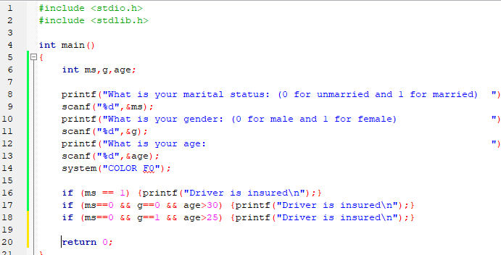

**OUTPUT**

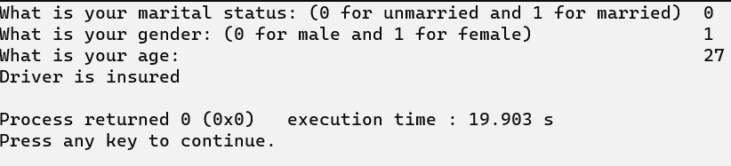

**Exercise 5: Print the following series using for and while loop**

Print numbers from 1 to 100 with increment of 1

Print numbers from 100 to 1 with decrement of 1

Print numbers from 20 to 2 in steps of -2

Print sequence of numbers: 2, 5, 8, 11, 14, 17, 20

Print sequence of numbers: 99, 88, 77, 66, 55, 44, 33, 22, 11, 0

**FOR LOOP**

**PROGRAM**

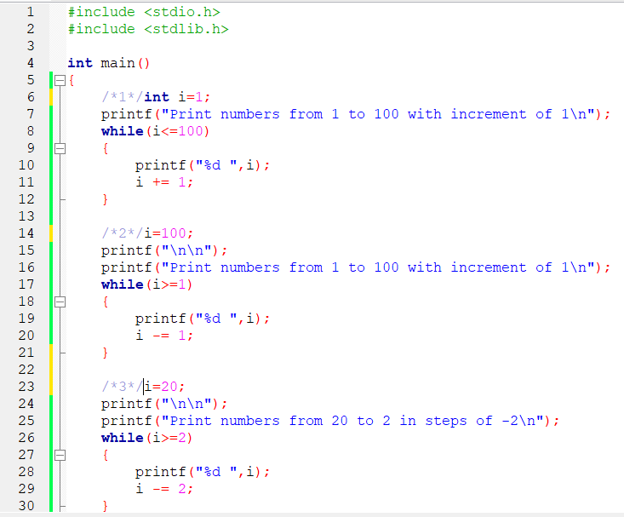

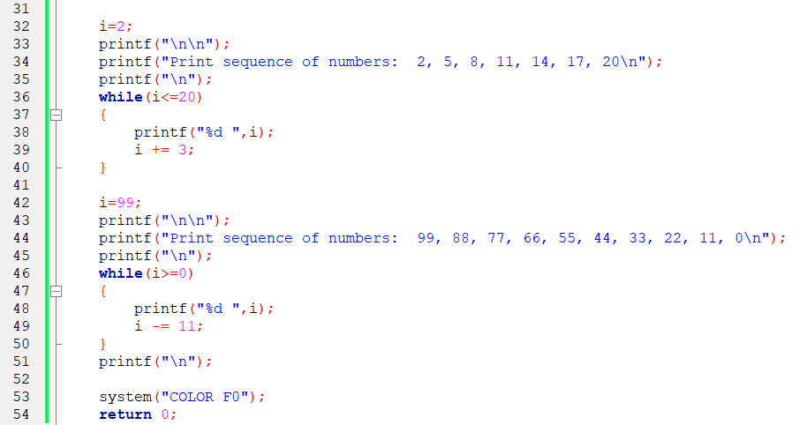

**OUTPUT**

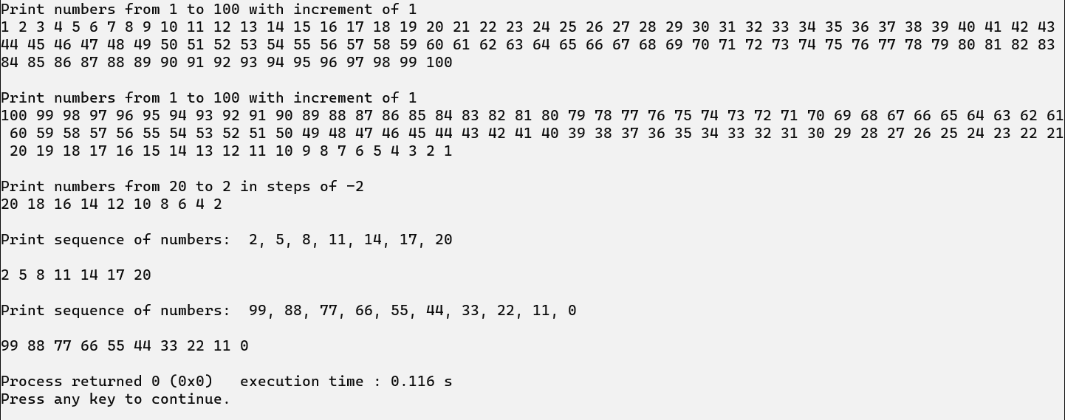

**WHILE LOOP**

**PROGRAM**

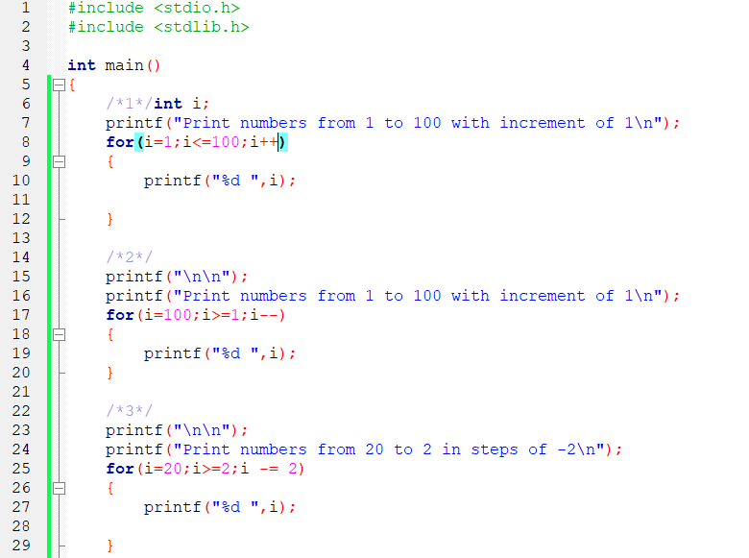

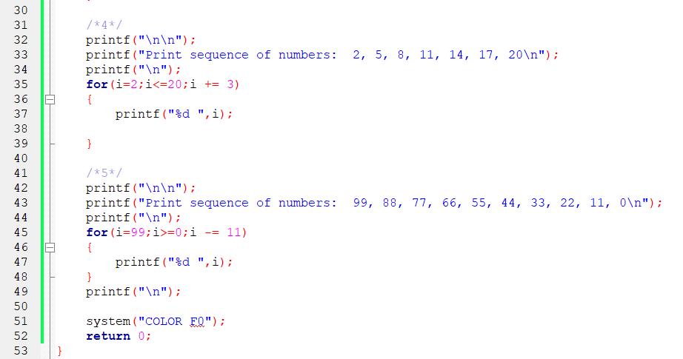

**OUTPUT**



**Exercise 6:** Write a program that reads in five integers and then determines and prints the largest and smallest integers in the group. Use loop to input the values from the user (Hint: use two of the variables to hold the current largest and smallest integers.)

**PROGRAM**

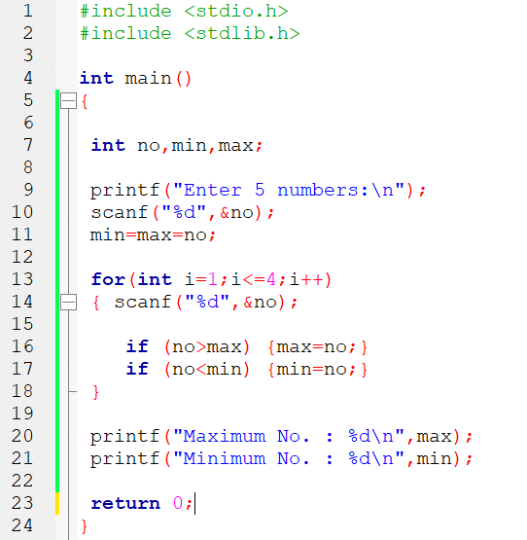

**OUTPUT**

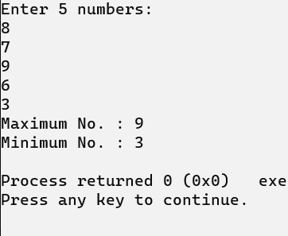

**Exercise 7:** Write a program that reads a number and determines and prints whether it is odd or even. (Hint: use the modulus operator. Any even number is multiple of two, and any multiple of two gives a remainder of zero when divided by two.)

**PROGRAM**

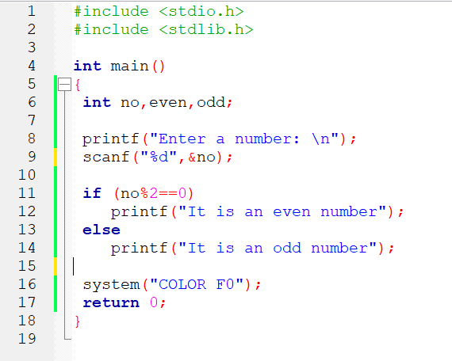

**OUTPUT**

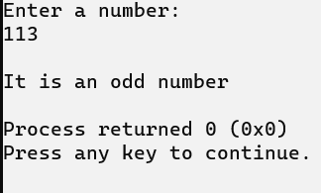

**Exercise 8:** Write a program which asks the user to enter 10 numbers and prints out the message “even” if the number is even and “divisible by three” if the number is divisible by three.

**PROGRAM**

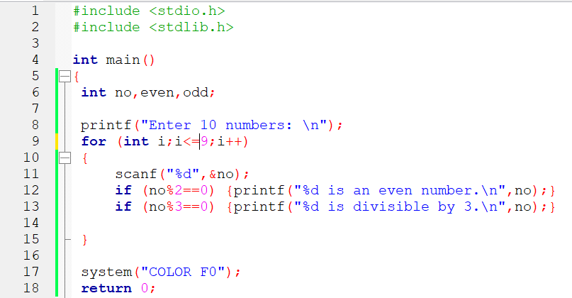

**OUTPUT**

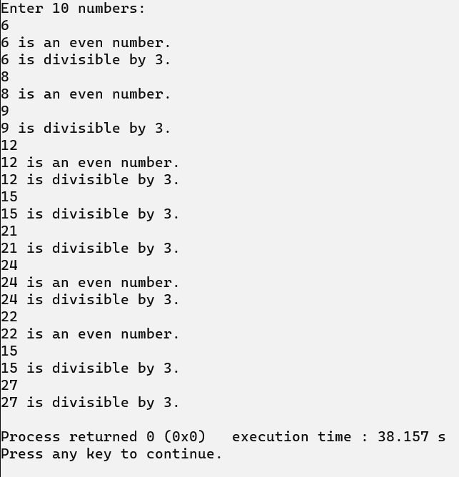

**Exercise 9:** A person invests $1000.0 in a savings account yielding 5% interest. Assuming that all interest is left on deposit in the account, calculate and print the amount of money in he account at the end of each year for 10 years. Use the following formula for determining these amounts:

a = p(1+r)n

where

p is the original investment(i.e. the principal)

r is the annual interest rate

n is the number of years

a is the amount on deposit at the end of the nth year.

**PROGRAM**

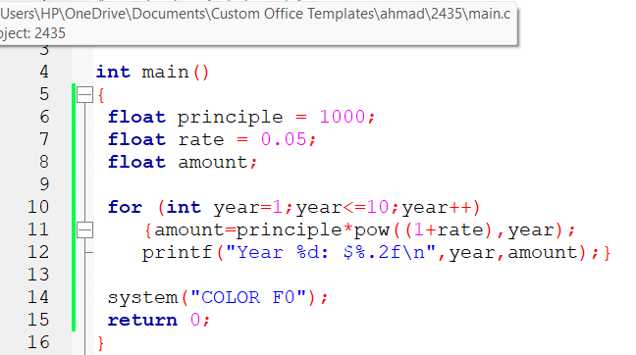

**OUTPUT**

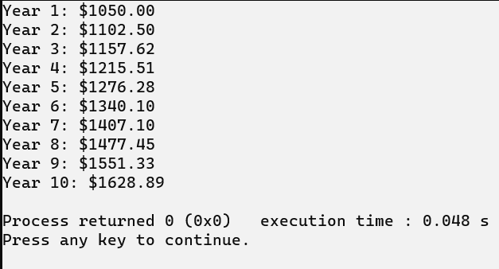

THE END